**HOW TO’S**

**How to create an instance in Amazon EC2?**

*Aakrati Sahu*

*Information Security Consultant*

*Netmonastery NSPL Mumbai*

*Contact- aakratisahu5@gmail.com*

Step 1. Create an AWS account.

1. Create an AWS account. Use this link for account creation - <https://aws.amazon.com/>

You will need to provide your Debit/Credit card details along with phone number where you will be called for verification purposes. AWS offers a Free Usage Tier, so that you can explore the services without being charged for a full year.

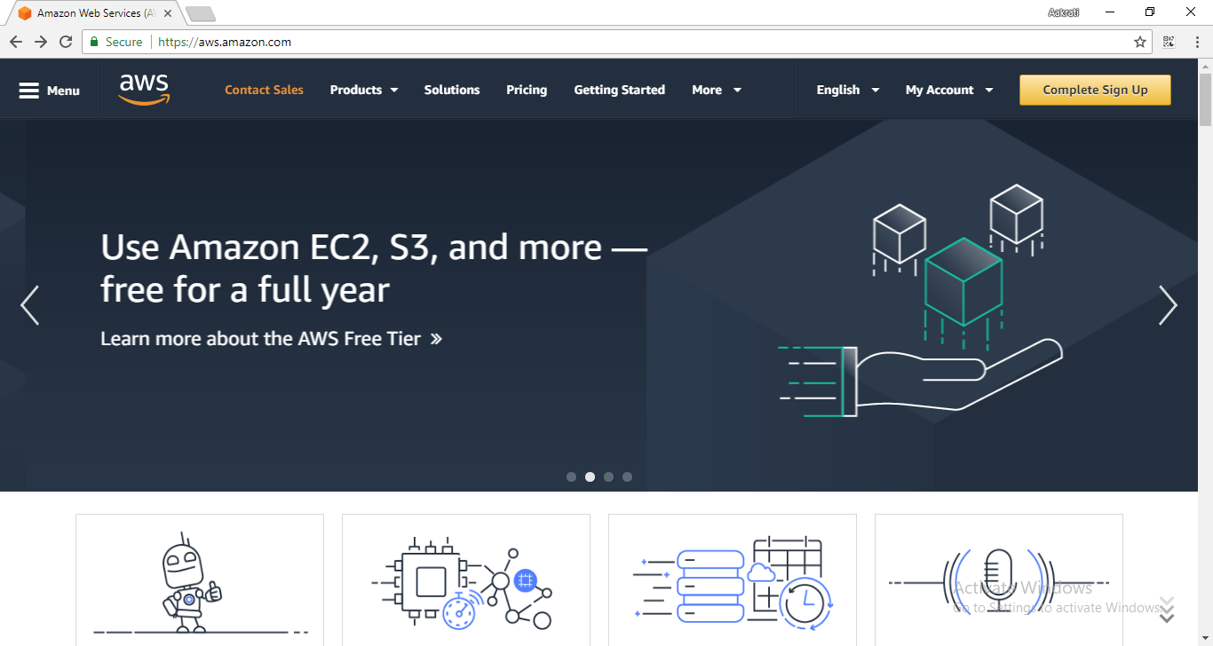

Step 2. Sign-in

Sign-in using the AWS Management Console using the following link-

<https://aws.amazon.com/console/>

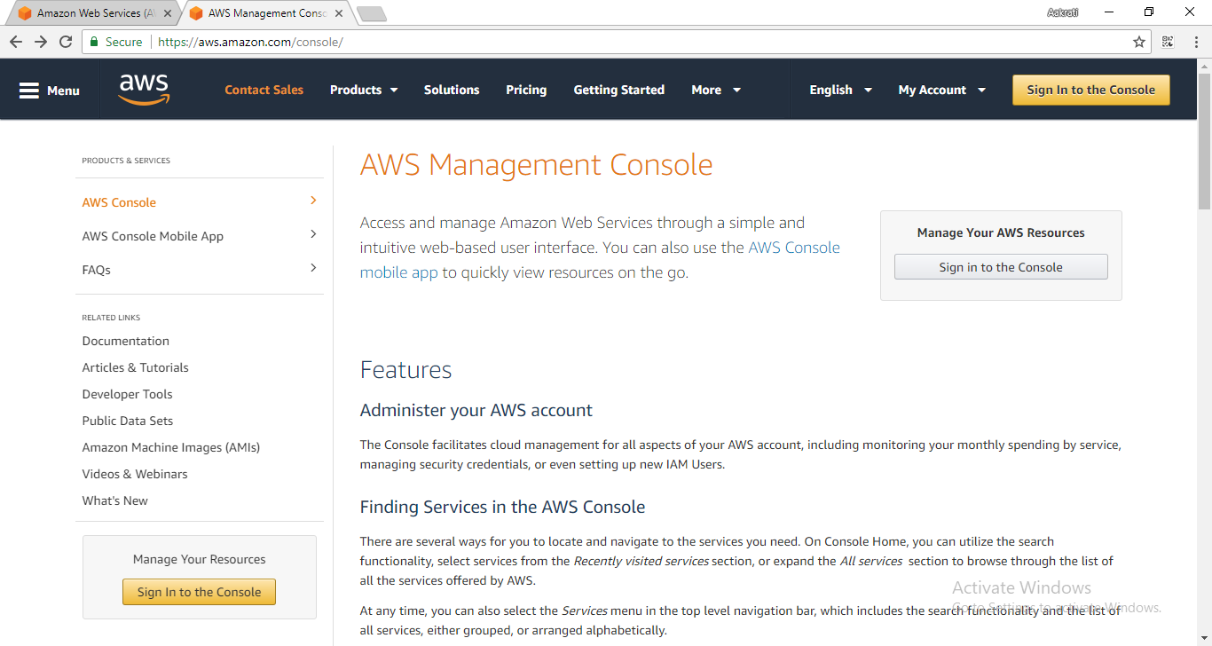

Step 3. Instance Creation

1. Go to “Services” and then select “EC2” under “Compute” option.

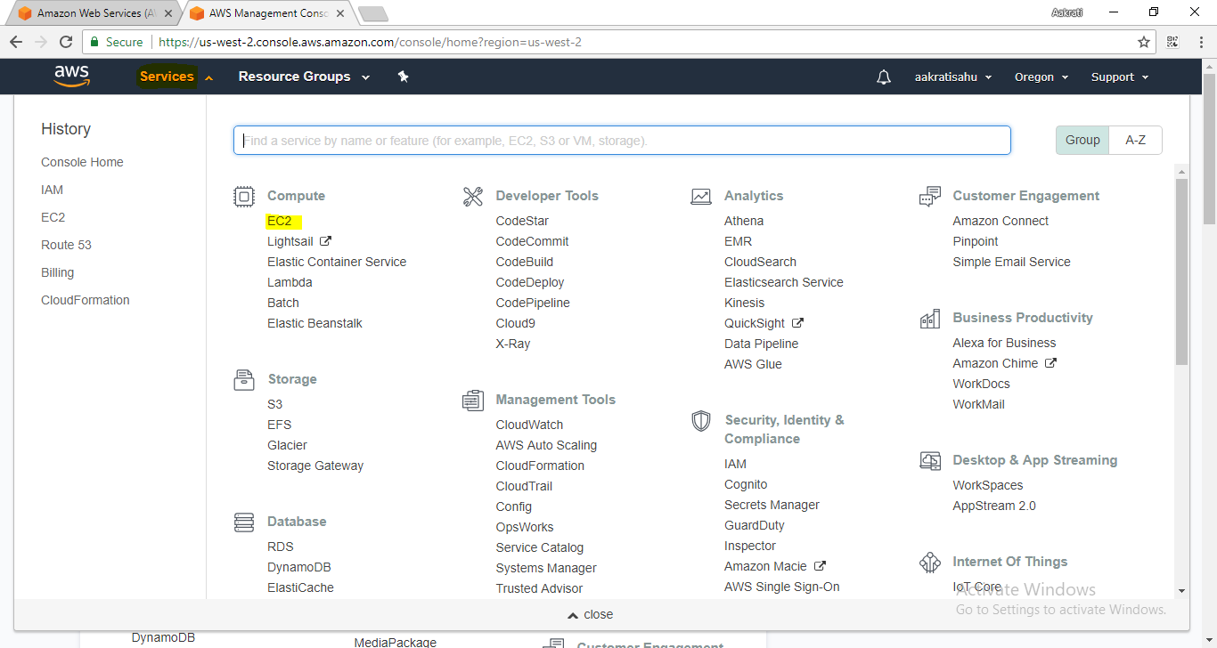

1. Go to Launch Instance as shown below.

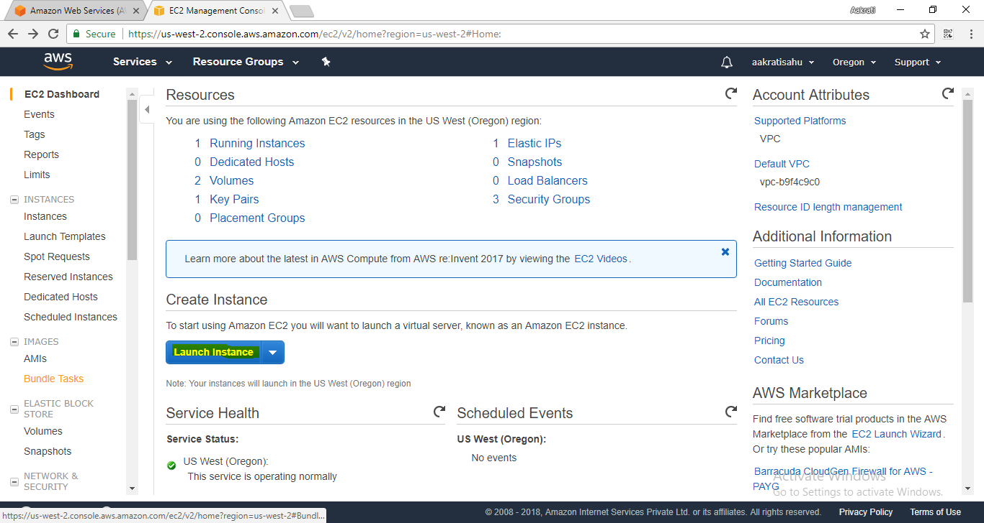

1. Now select an AMI as per the requirements.

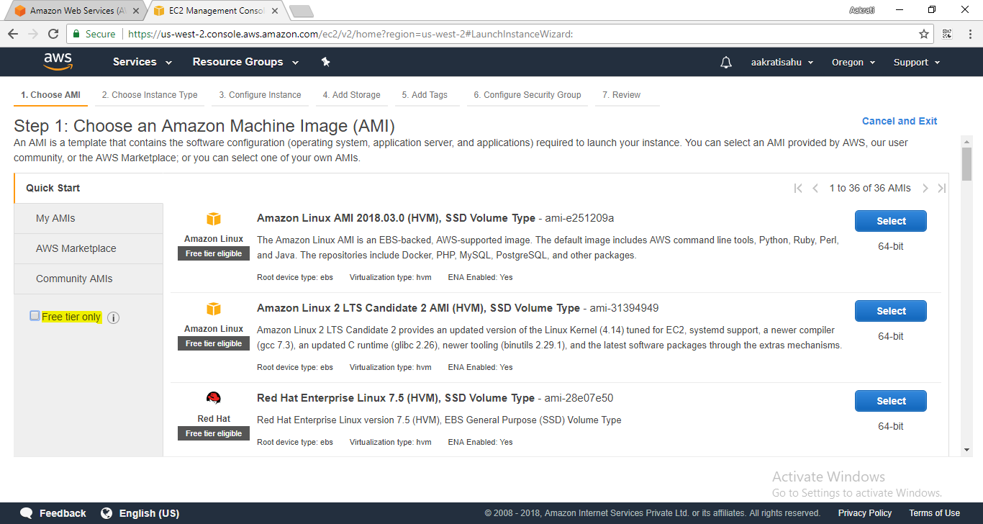

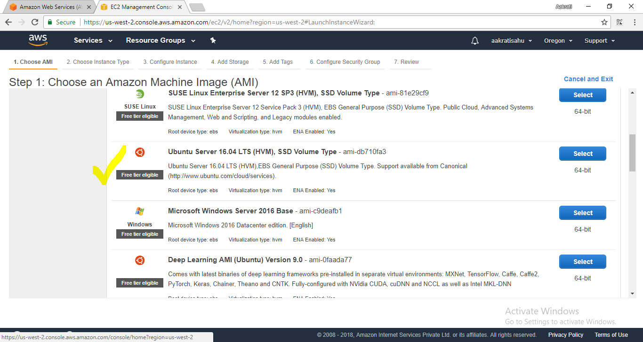

1. Choose Instance type.

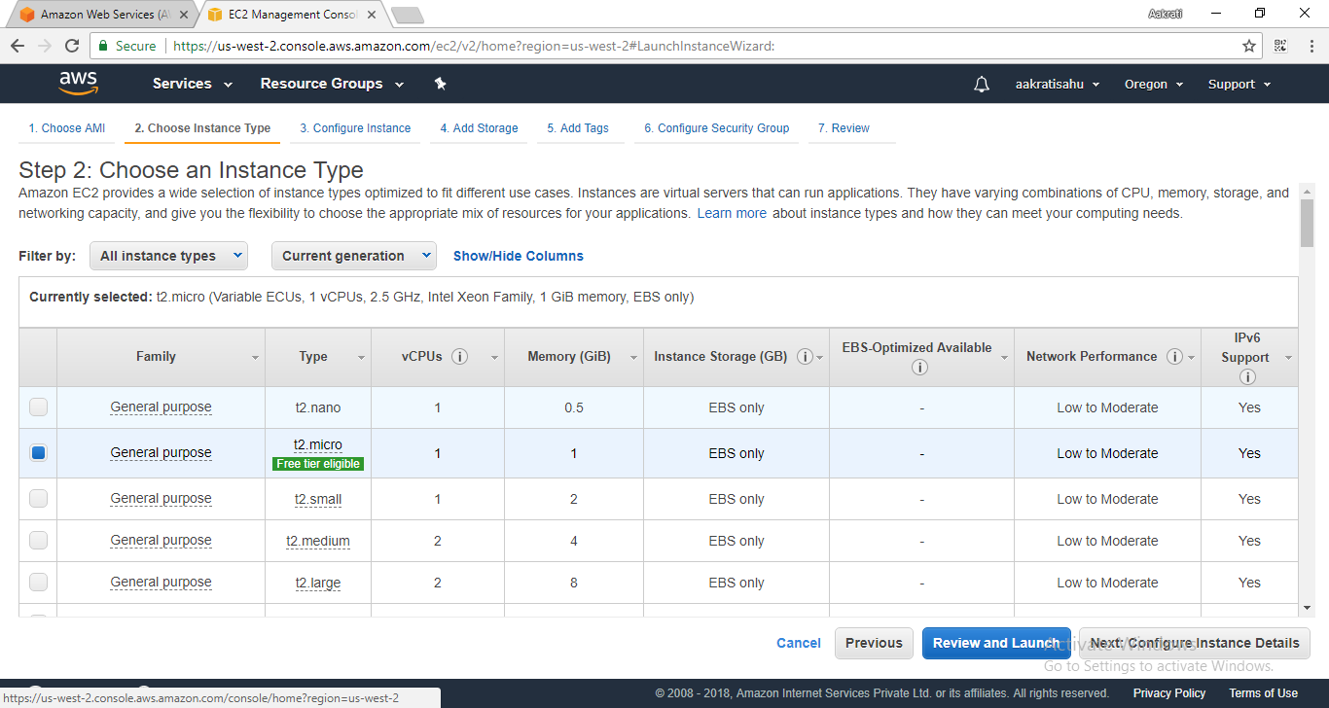

1. Configure Instance.

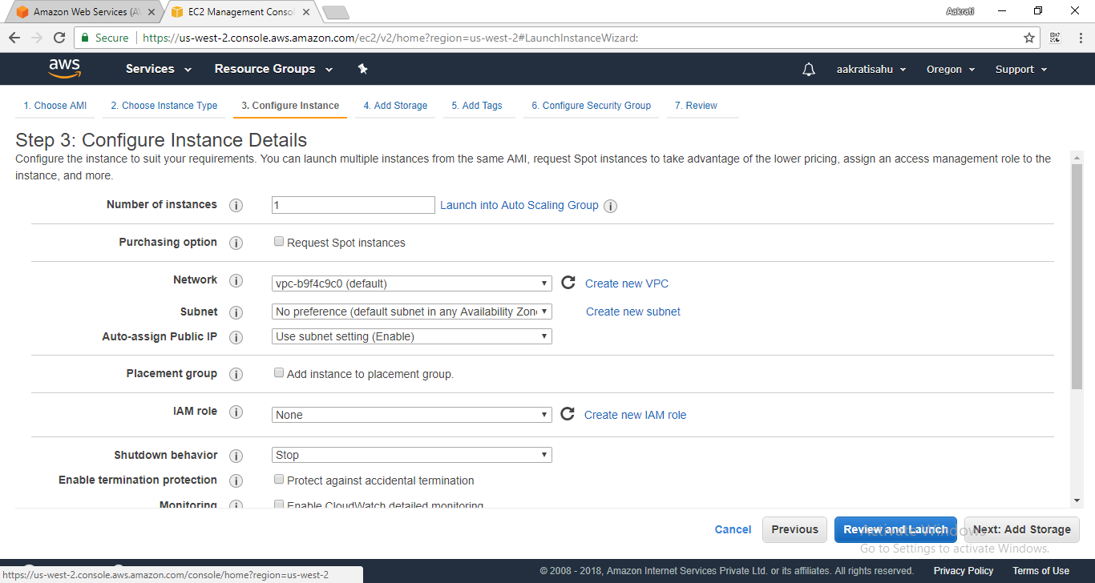

1. Add Storage.

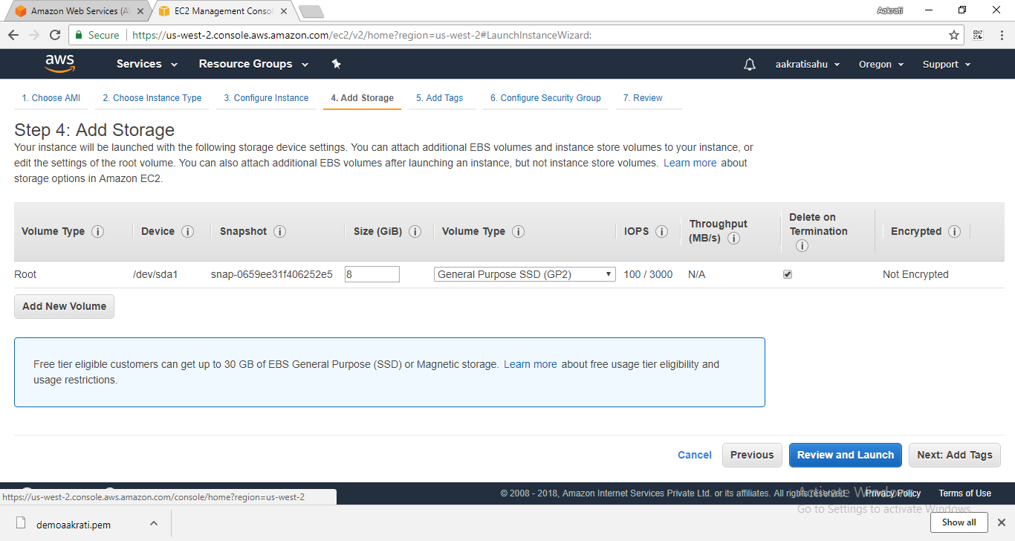

1. Add Tags.

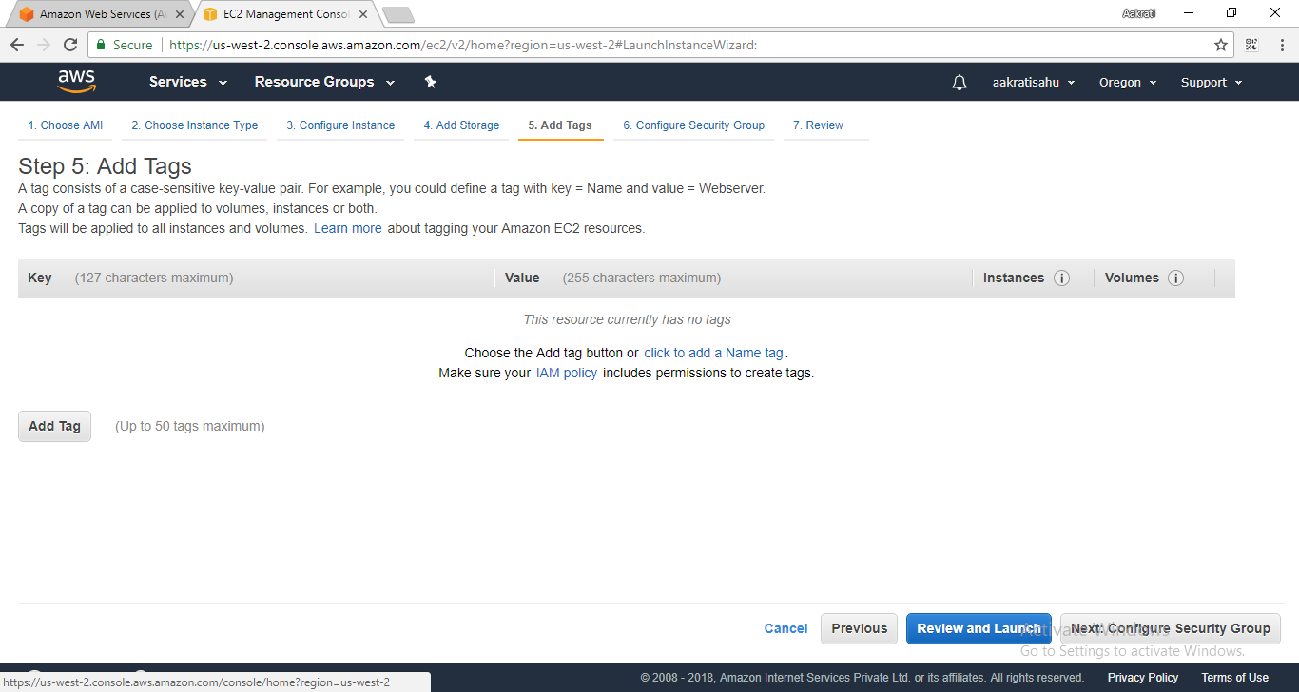

1. Configure Security Group.

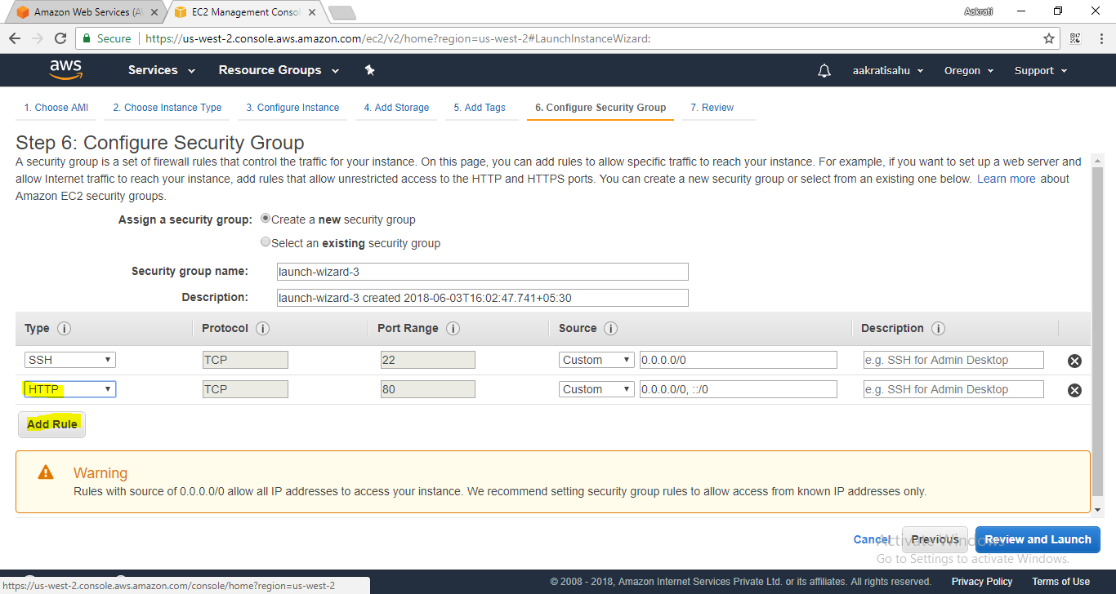

1. Review and Launch.

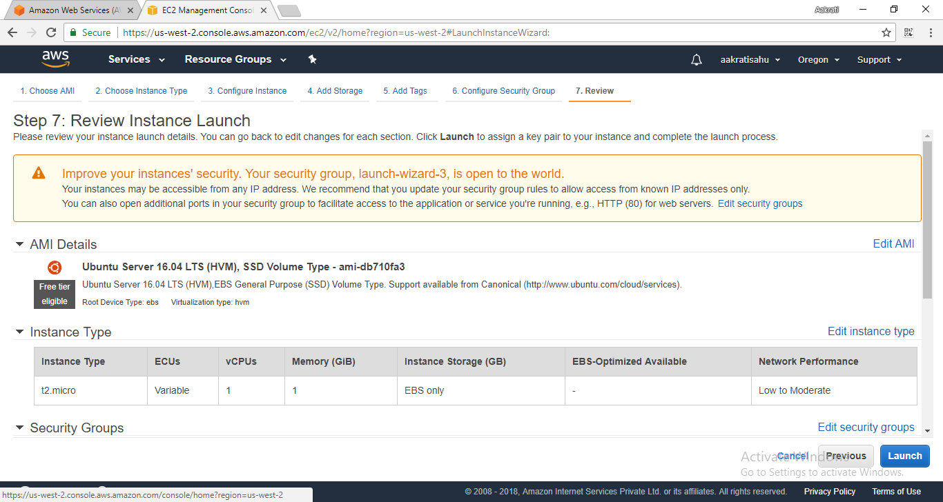

After launching, a pop up window will show up that will ask to either “Select an existing key pair or create a new key pair”

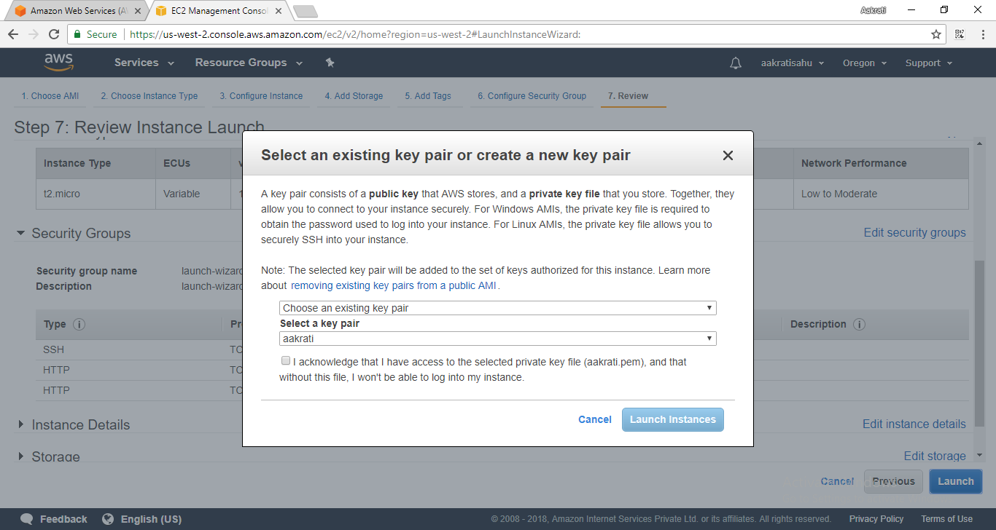

I am creating a new key pair here for demo purpose and giving it a name “demo.aakrati”.

Now download the Key Pair.

*It will save as a .pem file.*

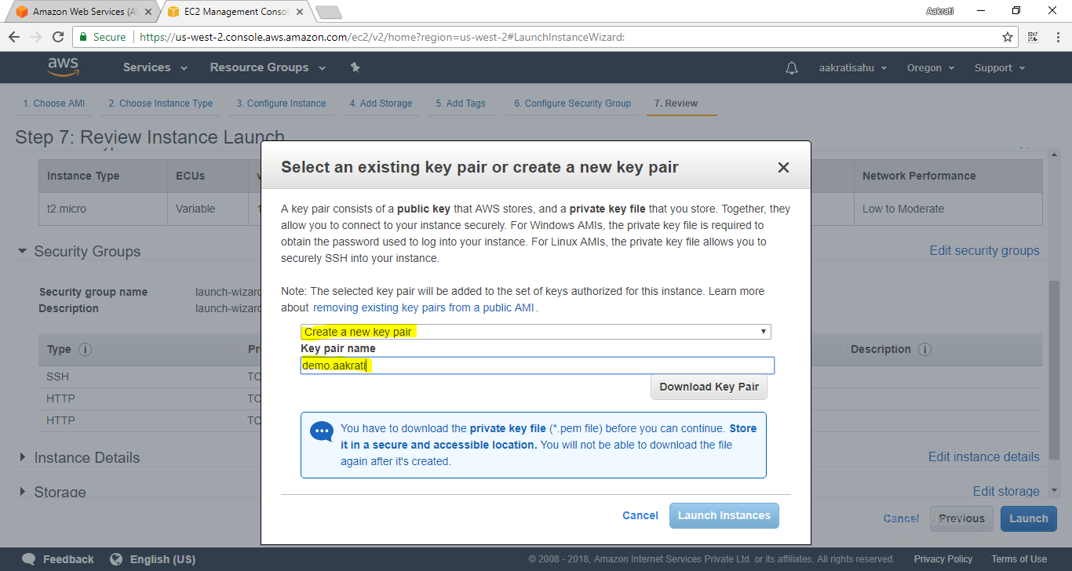

1. As shown below the instances are launching.

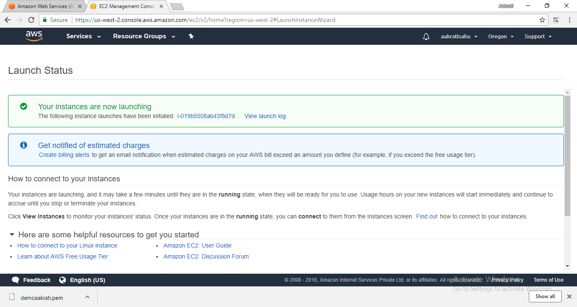

1. You can see your instances running successfully under “instances” tab.

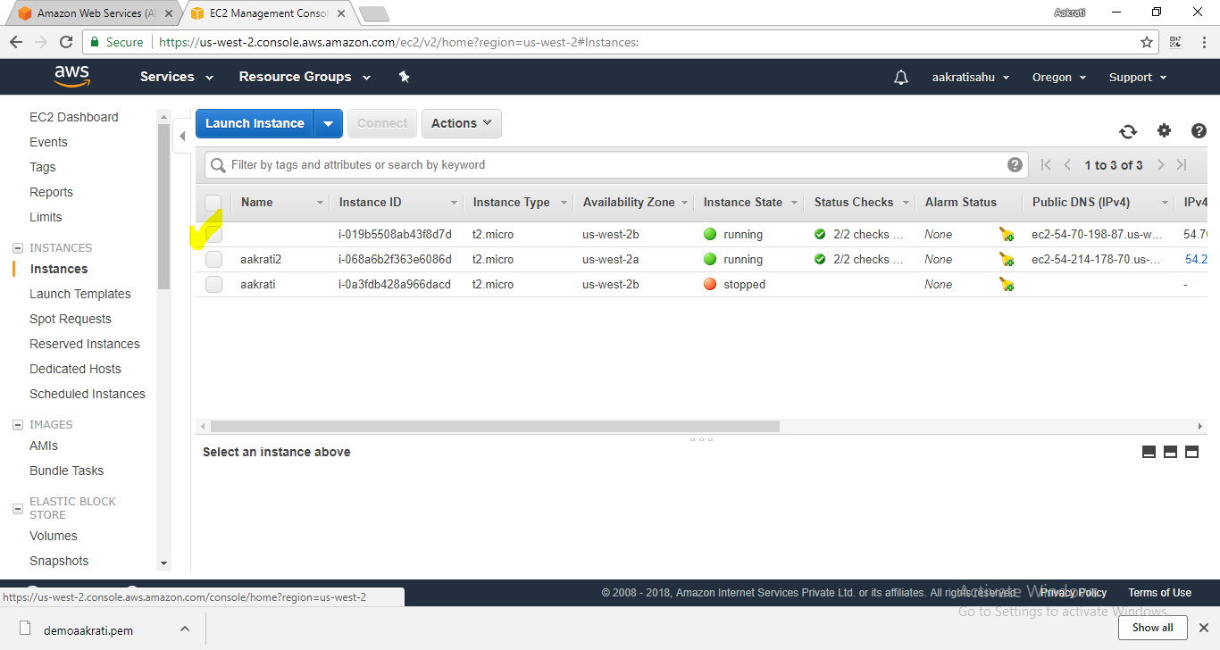

Also, you can name your instance as per convenience as shown below. Here, I am naming the instance as “demo.aakrati”.

